ELECTRIC CAR CHARGING STATIONS SURPASS
NUMBER OF FUEL STATIONS

There are now almost 1,000 more public places to charge electric cars than there are forecourts to pump petrol in the UK – 9,200 EV charging locations compared to 8,400 fuel stations.¹
These include all Nissan UK dealers, such as xxx, which is doing its bit to help increase the number of available electric vehicle charge points across the country.
The crossover happened more than a year before Nissan’s 2016 prediction of August 2020 – a result of the accelerating adoption of EVs (electric vehicles) amongst UK motorists.
XXX, [job title] at XXX Nissan commented; “With the LEAF, Nissan has been at the forefront of the electric vehicle revolution and customers of ours that have purchased one, absolutely love them.
“We’re also seeing more and more customers telling us that their next car will be electric so it’s important for us to do what we can to help develop the nation’s rapidly growing EV charging infrastructure.”
In less than a century since Britain’s first fuel station opened – November 1919 at Aldermaston in Berkshire² – the number of forecourts has peaked, declined and been overtaken by charging stations designed for battery, not combustion, powered cars.
[Table showing number of EV Charging Locations vs Fuel Stations in the UK – 2012-2019]
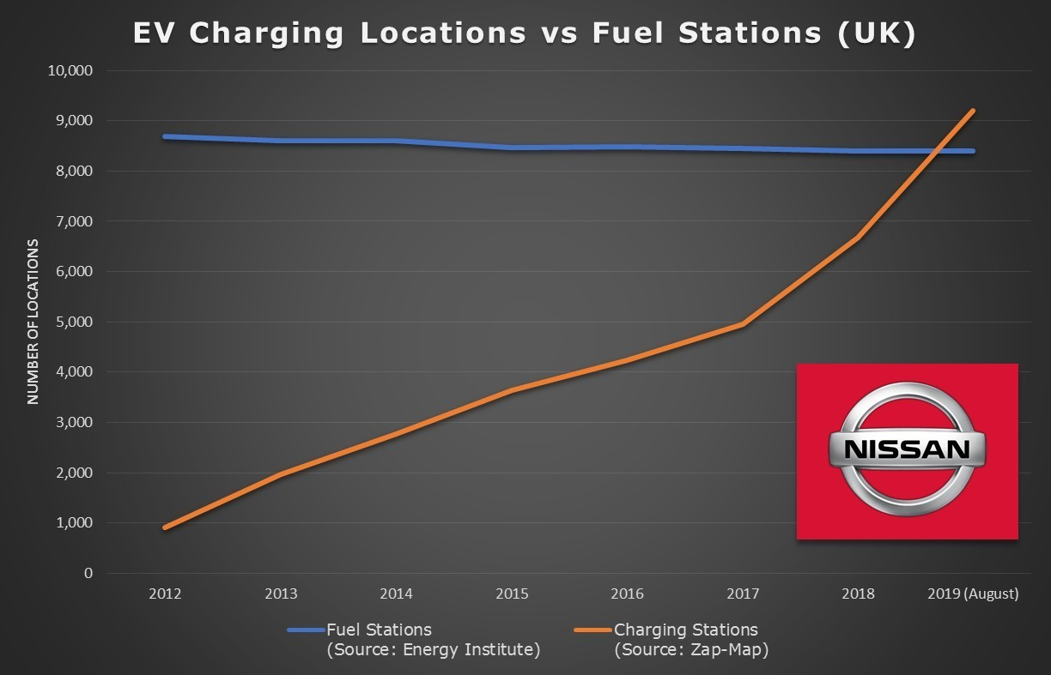

Almost 80% of UK petrol stations have closed since 1970, whilst the number of electric vehicle charging locations has increased from a few hundred in 2011 (when the Nissan LEAF went on sale) to more than 9,000 in August 2019.
Since Nissan launched the first mass-market electric vehicle – the LEAF – in 2010, EV technology has continually improved, with the latest models both affordable and practical for the majority of new car buyers. As a result, the UK is experiencing unprecedented growth in the demand for battery-powered transport.
In August 2019, compared to the previous year, demand for battery electric vehicles increased 158.1%, resulting in a 1.4% market share, the highest monthly market share on record.⁶
The new range-topping Nissan LEAF e+ costs from £35,895, including the £3,500 Government Grant and current offers include a £359 contribution towards a Home Charging Unit. With a higher capacity 62kWh battery pack, the new model delivers up to 239 miles (WLTP combined mode) of zero-emissions driving from a single charge.
More than 400,000 LEAFs have been sold globally since 2010 making Nissan the world’s best-selling electric vehicle manufacturer.
For more information, visit dealerwebsitehere

Editors Notes:

1. Primary data sources: Energy Institute (www.energyinst.org) & Zap-Map (www.zap-map.com)

2. Historic England, When Did England's First Filling Station Open?, 2012, https://historicengland.org.uk/listing/what-is-designation/heritage-highlights/englands-first-filling-station/

3. TFL, London Electric Vehicle Infrastructure Taskforce Delivery Plan, June 2019, http://lruc.content.tfl.gov.uk/london-electric-vehicle-infrastructure-taskforce-delivery-plan.pdf

4. The Economist, Running on empty, 15 August, 2015, http://www.economist.com/news/britain/21661001-though-plenty-gas-being-guzzled-filling-stations-have-become-scarcer-running-empty

5. Financial Times, New UK homes to have car charging points by law, 15 July, 2019
https://www.ft.com/content/57d2d7dc-a725-11e9-984c-fac8325aaa04

6. SMMT, New Car Registrations, 5 August, 2019, https://www.smmt.co.uk/vehicle-data/car-registrations/

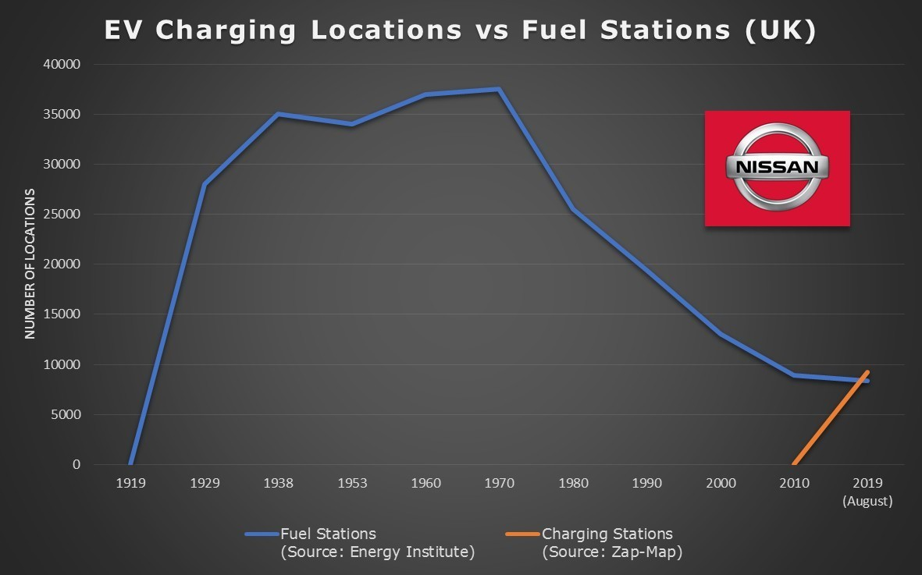

 | UK Fuel Stations | UK Charging Locations
1970 | 37,539
1980 | 25,527
1990 | 19,465
2000 | 13,043
2005 | 9,764
2010 | 8,892
2011 | 8,480
2012 | 8,693 | 913
2013 | 8,611 | 1,962
2014 | 8,609 | 2,775
2015 | 8,472 | 3,646
2016 | 8,489 | 4,232
2017 | 8,442 | 4,954
2018 | 8,396 | 6,669
2019 (August) | 8,396* | 9,199

* Data available to end of 2018
###
For further details please contact:
Dominic Vizor
Tel: (+44)07580 999016
dominic.vizor@nissan.co.uk
https://uk.nissannews.com/en-GB

About Nissan Motor Co., Ltd.
Nissan is a global full-line vehicle manufacturer that sells more than 60 models under the Nissan, INFINITI and Datsun brands. In fiscal year 2018, the company sold 5.52 million vehicles globally, generating revenue of 11.6 trillion yen. Nissan’s global headquarters in Yokohama, Japan, manages operations in six regions: Asia & Oceania; Africa, the Middle East & India; China; Europe; Latin America; and North America. Nissan has partnered with French manufacturer Renault since 1999 and acquired a 34% stake in Mitsubishi Motors in 2016. The Renault-Nissan-Mitsubishi alliance sold 10.76 million vehicles combined in calendar year 2018.
For more information about our products, services and commitment to sustainable mobility, visit
nissan-global.com. You can also follow us on Facebook, Instagram, Twitter and LinkedIn and see all our latest videos on YouTube.

