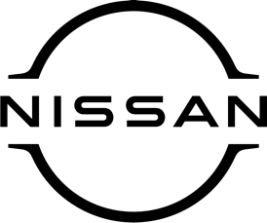

February 2021
For Immediate Release

Praise indeed! Tributes to Nissan’s Juke and
Micra as they are recognised at awards

Two of Nissan’s most popular models – the compact crossover Juke and iconic city car Micra – have won high praise from the judges of a prestigious automotive awards scheme.
The tributes came as the duo – both available at [DEALERSHIP DETAILS HERE] – enjoyed a double triumph at the 2021 FirstCar Awards, picking up sought-after ‘highly commended’ accolades.
The Juke (2010-2019) was successful in the ‘Most Wanted Used Car of the Year’ category while Micra received its award in the ‘New Car of the Year’ section.
Discussing the merits of Juke, David Motton, head of the judging panel and FirstCar editor, said: ‘‘Nissan’s pocket-sized crossover looks like nothing else on the road.
‘‘There’s lots of tech and gadgets, especially on the mid-spec Acenta model and above, and there have been loads of special editions with distinctive colours and styling tweaks.’’
Turning his attention to Micra, he described the car as ‘‘extremely safe, with a five-star rating from the experts at EuroNCAP and autonomous emergency braking as standard’’.
He added: ‘‘There’s also plenty of opportunity to personalise the looks, low running costs, and lots of standard equipment.’’
[DEALER PRINCIPAL NAME AT DEALERSHIP NAME] said: ‘‘Juke and Micra are two of our best-known and best-loved cars and we’re thrilled by the recognition they have received at this year’s FirstCar Awards.
‘‘They’ve both been particularly popular with our customers in recent years and we would urge people to get in touch to find out what all the fuss is about!
‘‘We can still communicate with customers in a Covid-secure way even though sadly the showroom doors remain closed at the moment.’’
FirstCar is the leading publisher in the new driver market and produces a wide range of resources to help educate young motorists.
Its award scheme recognises and rewards the best products and services within the new driver sector – and as well as a judging panel, more than 35,000 new drivers cast their votes to help decide the winners.

-ends-

Nissan Dealer PR: 07309 740052

