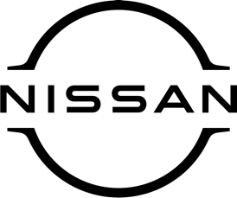
Press release
For immediate release

‘A car with the X factor!’ Nissan Juke is a
winner at prestigious awards ceremony

The Nissan Juke – available to inspect and test-drive at [DEALERSHIP NAME HERE] – has been named ‘Used Small Car of the Year’ by influential motor trade title Car Dealer Magazine.
The accolade was given to the British-built compact crossover at the 2023 Used Car Awards, organised by the magazine and held each year at The Brewery in East London.
Juke won praise for its eye-catching, individual styling, great levels of technology plus generous cargo space and roomy interior. Judges also highlighted its versatility, comfort and safety, making it a go-to option for thousands of used car buyers across the UK.
James Baggott, editor-in-chief of Car Dealer Magazine, said: ‘‘Used car buyers love the Juke, and it’s not hard to see why. Although a small car, it has a certain X-factor that really does appeal.
‘‘The second-generation model added a lot more substance to the original car’s daring design, such as a more spacious interior. As a result, it seems to have become even more popular recently!’’
TV presenter Mike Brewer, Used Car Awards host, said: ‘‘The Nissan Juke broke new ground when it was launched – it looked like nothing else on the road, and you can still say the same! It’s easy to park, cost-efficient to run and looks great – it’s a real winner in my book.’’
[NAME AND JOB TITLE HERE] at [DEALERSHIP NAME HERE] said: ‘‘Naturally, we couldn’t be more delighted that Juke has won this award – we’re feeling tremendously proud. Quite simply, Juke’s a great car and has been a key member of the Nissan line-up for over a decade now. Long may its success continue!’’
The Car Dealer Magazine Used Car Awards have been celebrating the top operators in the UK’s used car industry since 2012, rewarding manufacturers, car dealerships, workshops and exceptional people working in the sector.
For more information on new or used examples of Juke, and the many other great cars in the Nissan range, contact the friendly team at [DEALERSHIP DETAILS HERE].

-ends-

Nissan Dealer PR: 07309 740052

