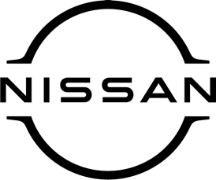

February 2021
For Immediate Release

Award triumph for Nissan as mighty
Navara picks up prestigious accolade

The Nissan Navara – now available at [DEALERSHIP DETAILS HERE] – has been named Pick-up of the Year by Company Car & Van Magazine.
The accolade was handed out at the magazine’s annual awards event, with the winners announced online because of the ongoing Covid-19 pandemic.
Tough, smart and refined, the mighty Navara boasts an advanced four-wheel drive system that can go virtually anywhere, plus a rigid chassis with the first multi-link rear suspension in its class.
Its high approach, departure angles and ground clearance mean Navara’s imposing presence can’t be ignored, yet its sleek aerodynamic shapes and distinctive LED lighting give it a fresh, modern look.
The current iteration of Navara represents the culmination of 80 years of Nissan pick-up production experience – and the award from Company Car & Van follows similar recognition in previous years from the likes of Honest John, Parkers and 4x4 Magazine.
Andrew Walker, editor of Company Car & Van Magazine, said: ‘‘Despite the global pandemic, Nissan have managed to make changes to Navara which have improved it and made it a very hard package to beat.

‘‘New Euro6d engines, NissanConnect Services, multi-link rear suspension on all models and an improved six-speed manual gearbox combine to make the Navara a deserved winner.’’

[NAME, JOB TITLE, DEALERSHIP] said: ‘‘Naturally we are delighted with this recognition for Navara. With its strong drivetrain, unbeatable value for money and cutting-edge technology, no wonder it is such a popular choice.

‘‘Navara is a vehicle we are incredibly proud of here at Nissan and it’s great to see it get the recognition it deserves. If you’re in the market for an award-winning pick-up, talk to us today.’’

Navara is available from just £22,975. Contact [DEALERSHIP DETAILS AND WEBSITE] for more information.

-ends-

Nissan Dealer PR: 07309 740052

