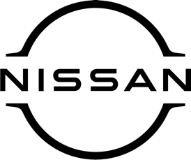

August 2021
For immediate release

Nissan LEAF is declared UK’s ‘Best Used
Electric Family Car’ by What Car?

The second-generation Nissan LEAF – on sale now at [DEALERSHIP NAME HERE] – has been named ‘Best Used Electric Family Car’ by the UK’s biggest car-buying brand, What Car?
LEAF gained the accolade at What Car’s 2021 Electric Car Awards, which recognise the best fully electric and hybrid models available today.
The judging panel praised Nissan’s ground-breaking EV for its ‘polished handling’ and ‘comfortable ride’ as well as occupant and boot space.
They said: “A truly viable alternative to the traditional family car, the LEAF is practical and good to drive, while its range makes it useful for more than just commuting. Overall, the 40kWh LEAF impresses next to its used rivals.”
The prestigious accolade is the latest in a number of official recognitions for LEAF in the growing used electric car market. The 2018 version was also named ‘Best Used Electric Car’ in What Car’s 2021 Used Car Awards.
Since its global launch in 2010, LEAF has seen enhancements to both battery capacity and performance from 24kWh to 30kWh in 2016. The second-generation model offers both 40kWh and 62kWh capacities, with an official range of up to 239 miles (WLTP) on range-topping e+ examples.
[NAME AND JOB TITLE] at [DEALERSHIP NAME] said: “We’re delighted that LEAF has once again been recognised as the most accomplished and affordable model in the growing used electric car market.
“As the original mass-market EV, LEAF continues to be an accessible entry point to all-electric driving for thousands of motorists, whether that’s as a used example or the latest generation LEAF e+. Get in touch with us today to find out more!’’
For more information about the all-electric Nissan LEAF, please contact [DEALERSHIP DETAILS HERE].

-ends-

Nissan Dealer PR: 07309 740052

