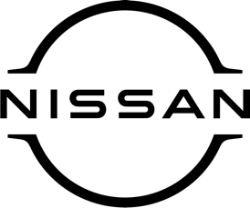

December 2021
For immediate release

Nissan LEAF e+ scores maximum
five-star rating from Green NCAP

The all-electric Nissan LEAF e+ – on sale now at [DEALERSHIP DETAILS HERE] – has often won praise for being clean, energy-efficient and kind to the environment.
And now, the car has gained a maximum five-star rating from the independent testing body Green NCAP after notching up a string of exceptional scores in a recent assessment.
Put through its paces in real-world and laboratory tests focusing on clean air, greenhouse gas and energy efficiency standards, the zero-emission LEAF e+ achieved a perfect rating in the first two categories.
Underscoring the intelligent design of the fully electric 62kWh powertrain, the LEAF e+ secured 9.9/10 for its impressive energy efficiency performance, with Green NCAP highlighting its innovative e-Pedal with regenerative energy technology.
LEAF e+ offers customers a compelling blend of efficient electric power and intelligent driver assistance technologies.
The model’s 62kWh powertrain yields up to 239 miles of range under the WLTP combined cycle, while the innovative e-Pedal allows drivers to accelerate, decelerate and stop using one pedal – maximising efficiency on the move.
Customers can enhance energy efficiency further with the model’s B Mode and ECO Mode functionalities, combining to maximise regenerative braking, optimise power output and conserve energy – providing confidence and reassurance on longer journeys.
[NAME AND JOB TITLE AT DEALERSHIP] said: “Since LEAF’s launch as the first mass-market electric vehicle in 2010, it has made sustainable, zero tailpipe emission mobility an attainable reality for many of our customers.
“The maximum five-star rating for the LEAF e+ awarded by Green NCAP is a powerful testament to the quality of the product, and the extensive expertise that Nissan has gained throughout a pioneering decade of innovation in electrification.’’
For more information on the Nissan LEAF e+, contact [DEALERSHIP NAME AND CONTACT DETAILS].

-ends-

Nissan Dealer PR: 07309 740052

