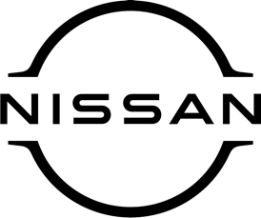
Press release
For immediate release

Nissan celebrates prestigious award
for all-conquering Qashqai

Nissan has begun the New Year in fine style, by collecting a prestigious award from the respected automotive title Company Car & Van.
The Nissan Qashqai – available to view and test-drive at [DEALERSHIP NAME HERE] – was voted SUV Car of of the Year 2024.
The editor of Company Car & Van, which publishes comprehensive company car and commercial vehicle reviews, said: ‘‘If you want a practical five-door SUV, the Qashqai e-POWER is hard to beat, with a large boot and clever practicality putting it ahead of its rivals.
‘‘In effect, the latest Qashqai carries on where its predecessors began, by being a good-looking SUV, with on-trend tech, excellent safety, and the clincher, the e-POWER drivetrain, which makes it our SUV Car of the Year for 2024.’’
A technology unique to Nissan, e-POWER uses a petrol engine and lithium ion battery to power an electric motor which drives the wheels. This delivers the same instant torque and smooth acceleration that electric vehicle owners love, but without the need to plug in.
[NAME AND JOB TITLE HERE] at [DEALERSHIP NAME HERE] said: ‘‘Naturally, we are delighted with this recognition for the Nissan Qashqai. As a proud Nissan dealer, we are of course aware of its many qualities and attributes but it’s always great when recognition comes from outside the company.
‘‘Last year, ARIYA was a winner at the Company Car & Van Awards and it’s great that Qashqai has followed in its footsteps. We thank the editor for his kind words, and for helping us get the New Year off to a successful start.
‘‘Drop in and see us soon to find out more about the Nissan Qashqai. Our friendly team will be only too pleased to demonstrate its many fantastic features.’’
For more information about Qashqai and the other great cars in the Nissan range, contact [DEALERSHIP NAME AND CONTACT DETAILS].

-ends-

Nissan Dealer PR: 07309 740052

